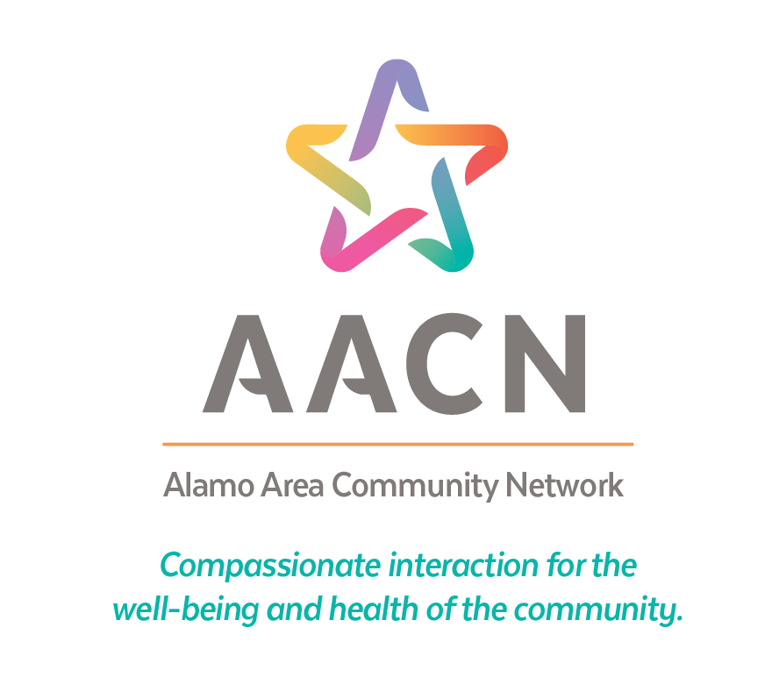

SYNC - AACN Referral Training Manual

Last Revised: 6/12/2025


Training Guide Table of Contents

Contents
Introduction 2
AACN/SYNC Structure 3
Goals of the AACN 4
SYNC Home Page 6
User Requests/Resource Library 7
Case Intake 8
AACN Authorization 9
Online Webform 10
Email Options 11
Texting Options 12
Manual Option 13
Generating Needs 14
Manually Enter Needs 15
PRAPARE Assessment 16
Managing Needs
Sending Referrals 17
Finding the right program 18
In-Network vs. Out-of-Network 19
Managing Needs

Closing Referrals 20
In-Network vs. Out-of-Network 21
Outcomes 22
Checking Outstanding Referrals 23

Introduction
Welcome! First, we want to thank you for being a part of our cross-sector network, which aims to improve collaboration and efficiency in the social service world. You’ve taken the first step to make referrals and care coordination much more efficient and transparent for yourself, your organization, and, most importantly, your clients.
This training manual is designed to assist end-users to navigate and use the SYNC platform for client referrals directly to programs that offer vital services in the community. While many other workflows exist on the SYNC platform, this training manual is specifically for the AACN Referral system.

Difference Between SYNC and AACN
To avoid any confusion about the terminology used in this manual, we’d like to
clarify what we mean when we say SYNC and what we mean when we say AACN.

SYNC (Supporting Your Needs in our Community) is the platform in which your case management work will be completed. This system is powered by Salesforce and is constantly being improved to ensure its efficacy with our main client, you, the user, in mind.
The AACN (Alamo Area Community Network) is the organization behind SYNC. We manage the platform and ensure that any issues are promptly addressed. We also conduct training to ensure that our end-users have adequate knowledge and tools to refer their
clients with ease and precision in the SYNC platform.

Goals of the AACN

The AACN is an alliance of Community-Based Organizations (CBOs) working to improve the health and well-being of individuals and families in the San Antonio region. In saying that, we have specific goals we are looking to achieve:
- Increase collaboration among partner agencies
  - With this platform, we aim to make it much easier for CBOs to communicate client needs with each other and encourage even more collaboration between partner agencies.
- Identify patterns in client needs
  - Using the data collected from the work in SYNC, we will be able to better understand the larger trends of client needs within our community.
- Capture Social Determinants of Health (SDoH)
  - We seek to better understand the barriers that community members face when it comes to their health and well-being outside of direct medical care.
- Reduce duplication of services across partners
  - With access to client records, participating organizations can see the previous referrals that have been made for their clients. In addition, you will also be able to see which organizations have worked with the client.
- Identify gaps in services for unmet needs
  - With better data, we can more easily understand what needs there are in specific service areas. With this information, we can provide a better picture of the service landscape to funders who are equipped to address these gaps.
- Create efficiencies and accountability from client to CBO
  - Using the client record, we have a longitudinal record of the organizations that have worked with the client and can see the outcomes of referrals made on their behalf.

SYNC Home Page
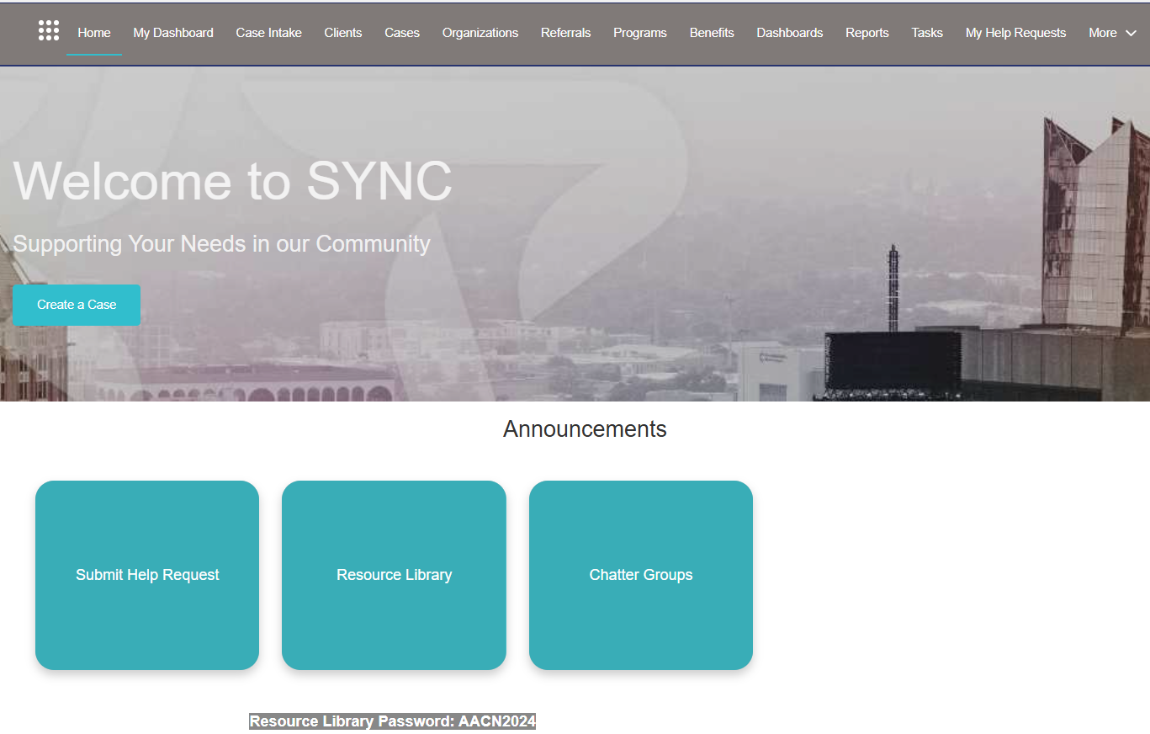
First, you’ll want to familiarize yourself with the SYNC Home Page. It serves as the foundation for all your work on this platform. From the Home Page, you’ll be able to access any client, case, or referral that you have worked on with ease.
The main features of the Home Page you will use to navigate are:
- The My Dashboard tab is where you can view any of the cases you are managing for your clients.
- The Referrals tab is where you can check the status of any outstanding referral that you have sent or that has been sent to you.
- The Submit Help Request button is your way of letting the AACN Team know what issues you are facing in the system.
- The Resource Library contains important documents that you may need to be successful in SYNC.

User Requests
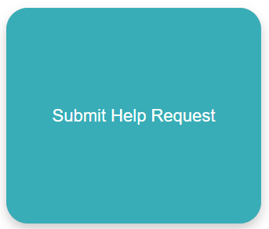
The best way of letting the AACN know when there is an issue within SYNC is to submit a User Request. The AACN team monitors these requests daily to ensure that issues are resolved in a timely manner.
Here is how to submit a User Request:
- Click on the “Submit Help Request” button
on the SYNC Home Page.

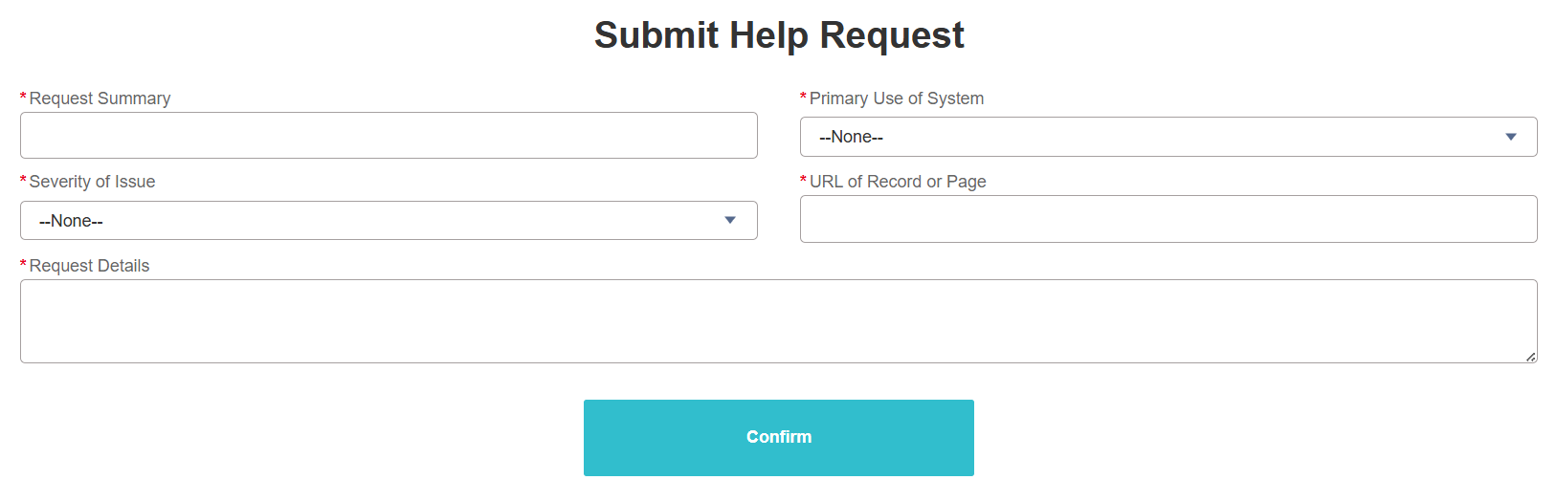

- Fill out each field as accurately as possible
  - Request Summary: A very brief description of the issue
  - Primary Use of System: Tell us which workflow you were using when you experienced the issue.
  - Severity of Issue: How much is this issue impacting your ability to help your client?
  - URL of Record or Page: Please provide the URL where you found the issue.
  - Request Details: Provide a more in-depth description of the issue and include case numbers. Please be sure to include the name and/or case number of the client so the AACN team can easily find them.
Resource Library
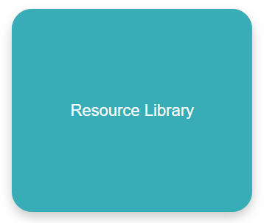
The Resource Library is a repository for important documents that SYNC users will need throughout their experience in the platform. This is a living web page that will be constantly updated, so it is important for users to check in regularly to see new documents that have been added. The AACN Team will also communicate when new documents have been added.
To access the Resource Library:
- Copy or memorize the password that is located underneath the Resource Library button. Then click the Resource Library button.

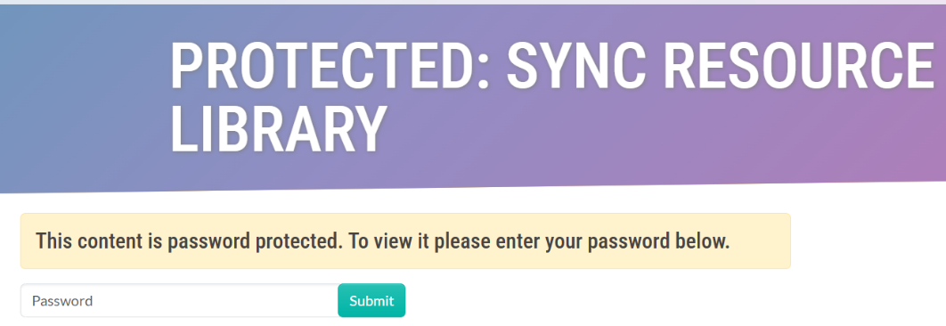
- When you click the button, you will be taken to a password-protected page on the AACN website. Enter the password and click Submit.
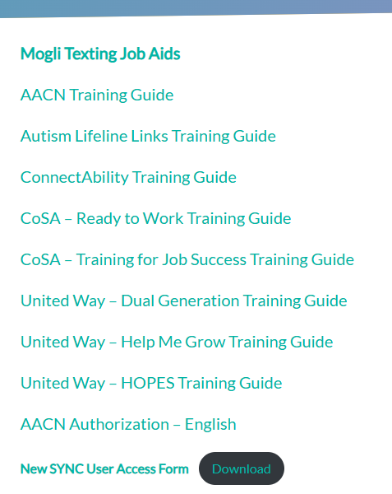
- Use whichever document you need to complete your work in SYNC.

Case Intake – Search/Create Client Case
Now that you have a solid grasp of how to navigate SYNC, it’s time to add your client to the system. This data entry is the gateway to helping your clients with SYNC.
Importance of Preventing Duplicate Records
Before adding your client, we will need to ensure that the individual is not already in SYNC being serviced by another organization. This is because each SYNC record acts as a longitudinal record, so that we can see what services and resources have been provided to the client all in one place. We want to avoid duplicates so that the information is not spread out over multiple records.
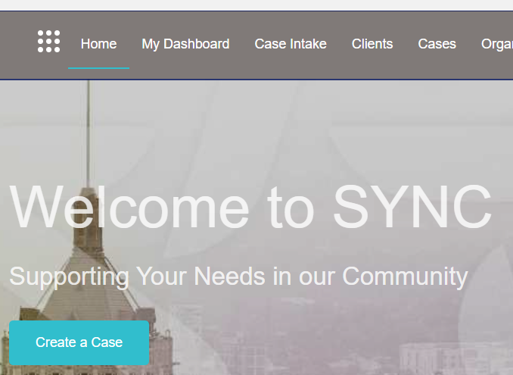
Search/Create Client

- From the SYNC Home Page, click
either “Create a Case” or “Case
Intake”.

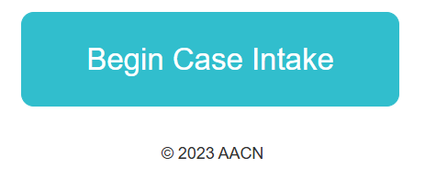
- On the next page, click on “Begin Case Intake”.

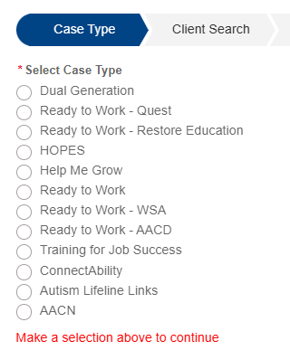

- Select which type of case you want to open for your client. Your access will determine which cases you will be able to create. For this workflow, select “AACN”.

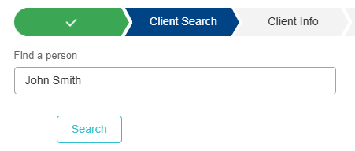
- Search for your client to see if they are already in SYNC and click “Search”.

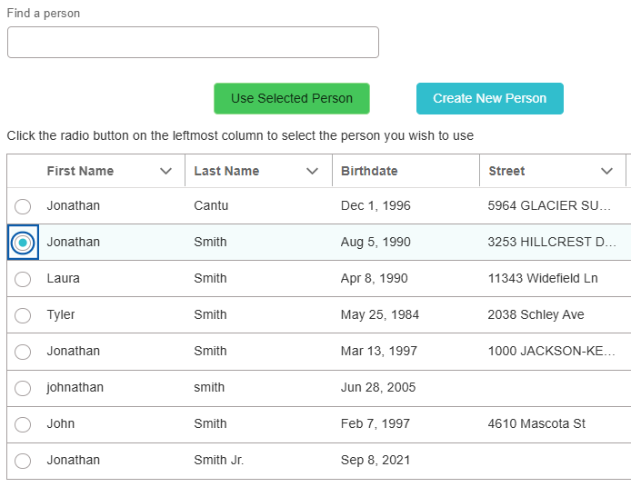

- If you identify your client based on the information that is displayed, click the circle to the left of their name and then click the “Use Selected Person” button. If they are not on the list, then click the “Create New Person” button.

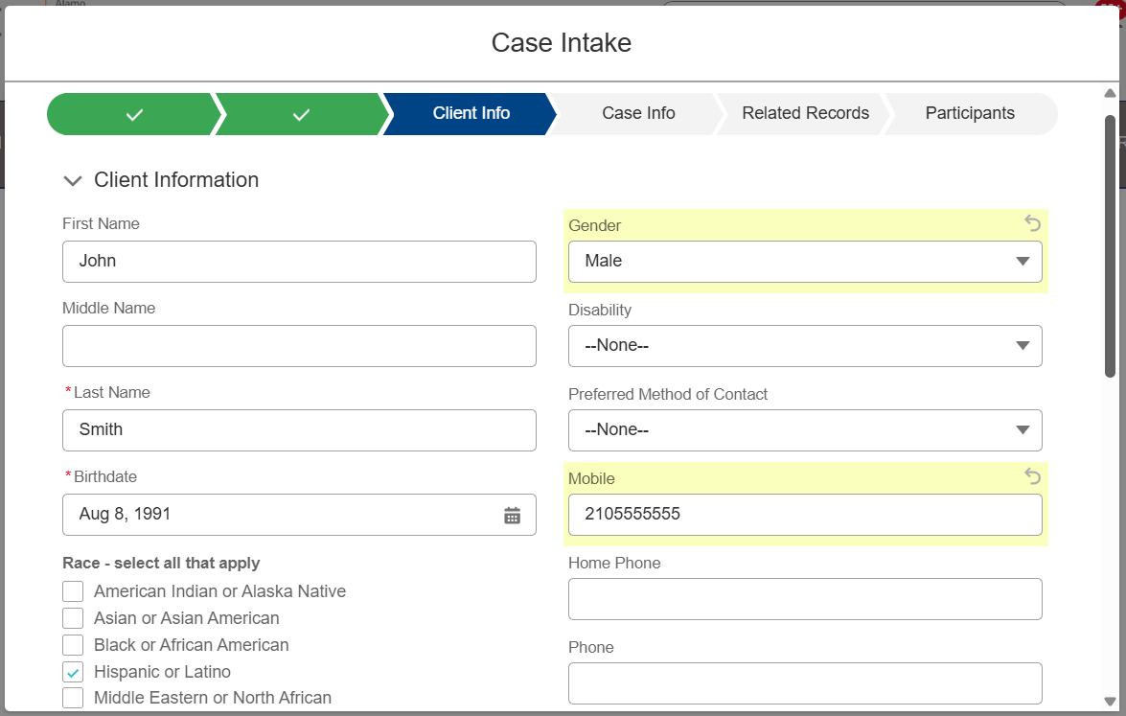
- Fill out as much information as you have for the client. The only required fields are their last name and date of birth. However, the more information you enter, the easier the referral process will be later on down the line. At a minimum, we recommend entering the following information:

  - First Name
  - Last Name
  - Date of Birth
  - Race
  - Address
  - Gender
  - Email
  - Phone Number

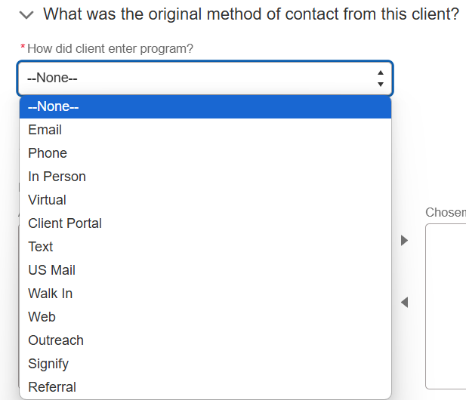
- On the next page, enter how the client came to your organization in the first place. You can also add additional information on this page if your client was referred to your organization outside of the SYNC platform. Click “Next” at the bottom of the page.

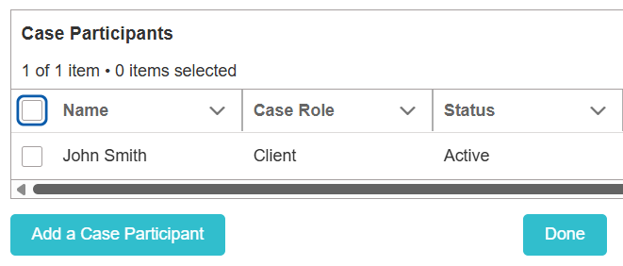
- At this point, you can add additional people in the household to by clicking “Add Participant” and you will search for and then create your additional clients like you did with the initial client. Or if there is only person to add, can click “Done”.

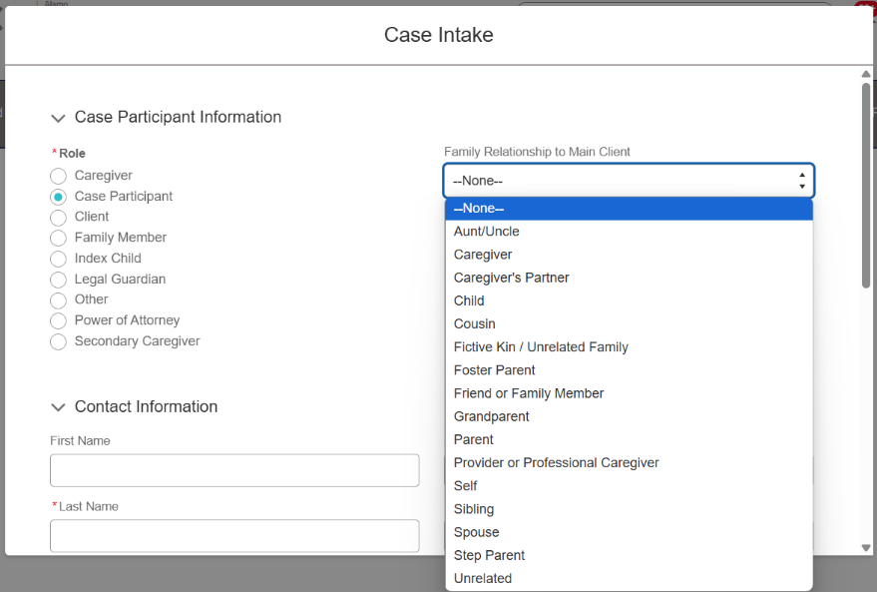

- If you add additional people, you must indicate the relationship between the added participants and the original client.

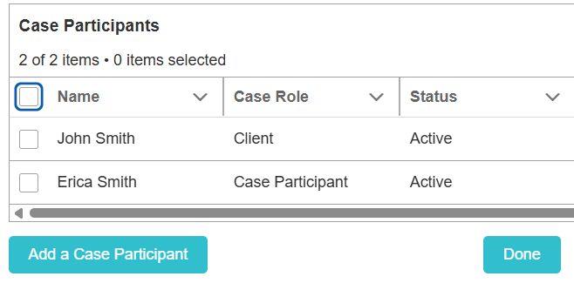
- You can continue to add as many people in the household who will need referrals for resources as necessary. Once you have added everyone you need to, click “Done”.

AACN Authorization
For you to be able to send referrals for your client, you must have them sign the AACN Authorization form. This form allows the client to better understand our network and provide their consent. We have made this form simple and easy to understand so that the client knows exactly what they are signing up for and what information can and can’t be shared. There are multiple ways you can have your client fill out the form:
- Email
- In-person
- Physical copy
- Text
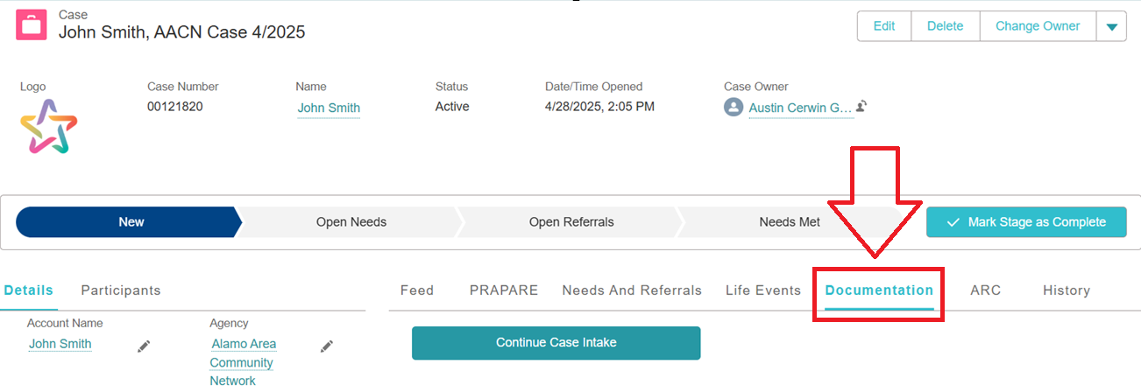
For all versions, you will first go to the Documentation tab on your client’s case record.
Scroll down to the “Document Checklist Items” (DCI) section and click “AACN Authorization”
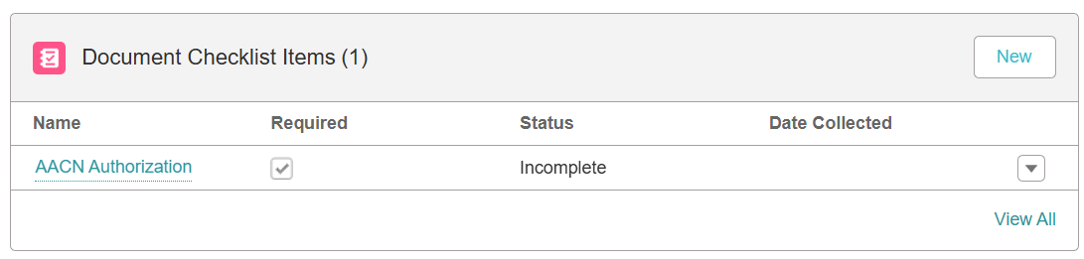

AACN Authorization: Email
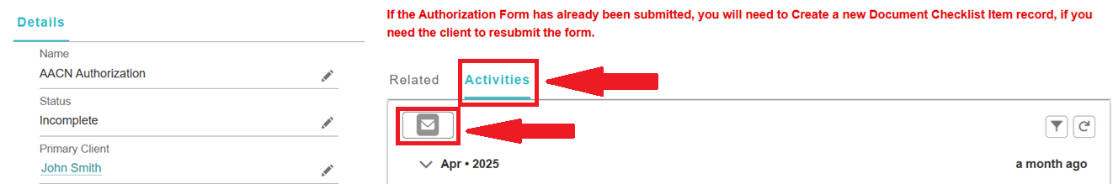
From the AACN Authorization Document Checklist Item, click Activities and then the email icon right underneath.
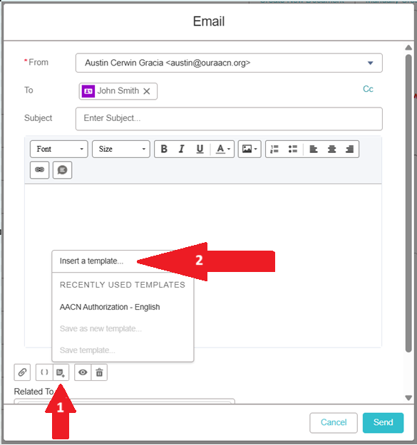
Email functionality will then populate and automatically enter your SYNC email in the “From” line and your client’s email in the “To” line, if you have already obtained their email address.
- Click the template icon towards the bottom, which looks like a sticky note with a “+” sign.
- Click Insert a template
- Under the drop list All Lightning Templates, choose the template in the language best suited for your client
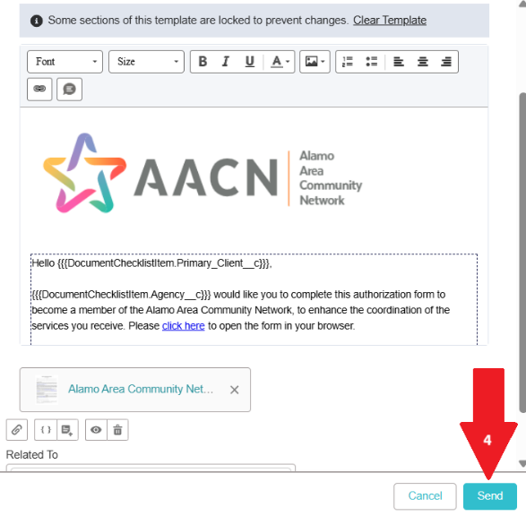
- The template will populate and will automatically add the client’s name and your organization when it gets sent. Click the Send Button.
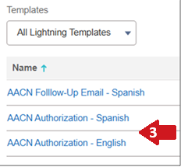

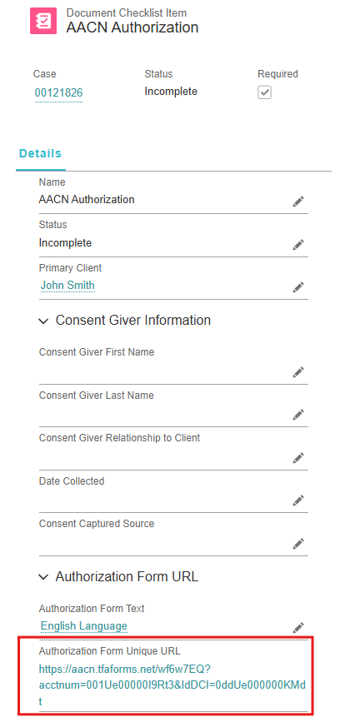
AACN Authorization: In-Person
If your client is with you in person, the best way to have them sign the AACN Authorization may be the simplest.
Scroll down on the AACN Authorization Document Checklist Item to find the Authorization Form Unique URL.
Click this link and let them fill out the form by turning your computer screen around for them or handing them the tablet you are working from.
Once they click submit, SYNC will recognize that the authorization has been submitted, and you will see a green check mark under your client’s name that lets you know the authorization has been completed.
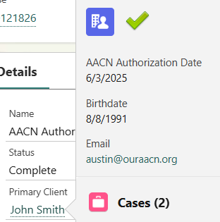

AACN Authorization: Physical Copy
If it works best for you and the client to have them fill out a physical version of the authorization form, here are the steps:
- Provide your client with the physical version of the authorization – you can find this in the Resource Library, or they can print out the PDF that is attached when you send them the AACN Authorization template email.
- The client will then fill out the form and give it back to you.
- Scan this document or take a legible picture so you have the file on your computer.
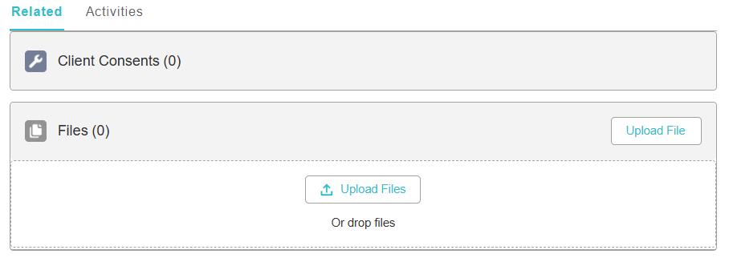
- In SYNC, go to the AACN Authorization Document Checklist Item.
- Under the Files section, click Upload File, and on the next screen, click Upload Files.
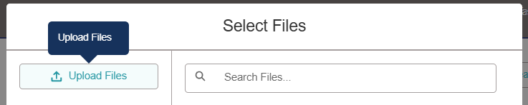

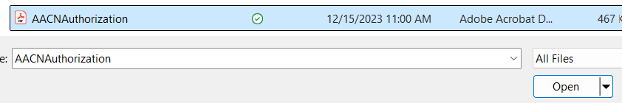
- Find the document you scanned to your computer and click Open.
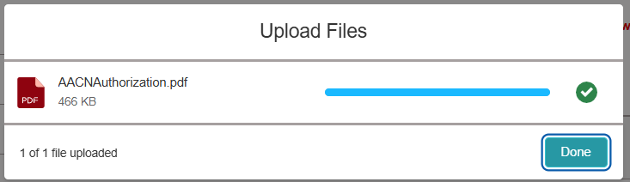
- When the form is finished uploading, click Done.

- Then, click on Manually Enter Client Consent within the AACN Authorization DCI.
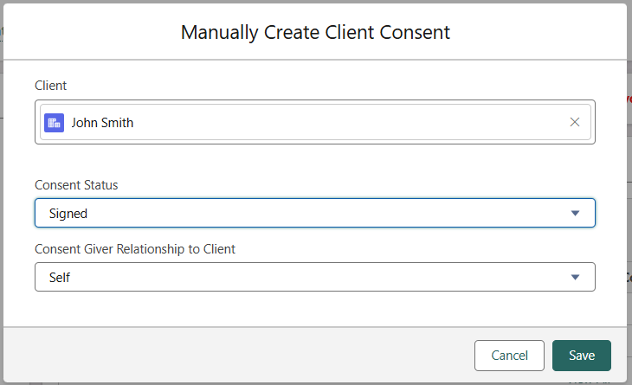

- Change the Consent Status from Unsigned to Signed. Then click Save.

- You will now see a green check mark next to your client’s name if you hover over it.

Generating Needs
The next step in the process is to identify the client's needs and enter them into SYNC. Adding needs to the client’s record is an important step because you can use them as a longitudinal record where you and other SYNC users can see what work has been done for this client and what resources the client has been connected to. In addition, the needs also serve as a roadmap to help you determine which referrals to make.
There are two ways to add needs to the client’s case record:
- Manually enter the need
- Use the PRAPARE Assessment

Generating Needs: Manually Enter the Need
Manually entering the needs will be the best option if you are able to uncover the client’s needs either through the flow of your conversation with them or if your organization has a needs assessment that you already use. In this case, we can just take the needs the client has shared with us and enter them directly into the system. Here’s how:

- Go to the Needs and Referrals tab on the case record.
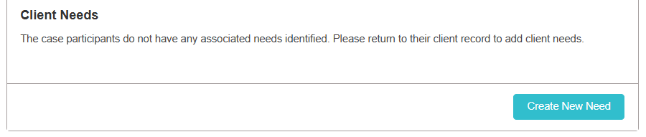
- Scroll down to the Client Needs section and click Create New Need.

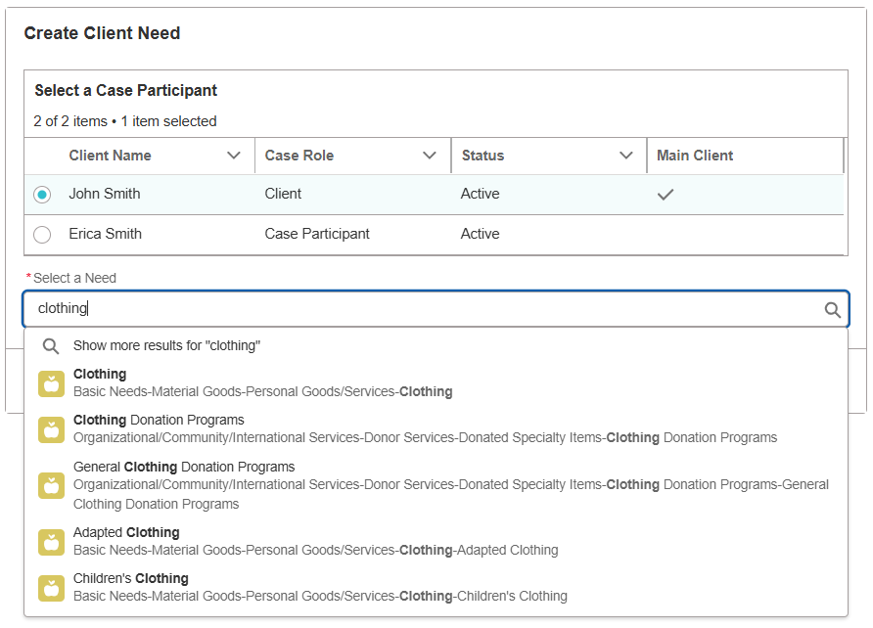
- Select the client who has the need. In the search bar, begin typing in the need the client has shared with you. Either select one of the needs that appears in the dropdown list or click “Show more results…” to see if there is a need better suited for the client. Select the need and click Next.

NOTE: The selection of needs comes from the AIRS taxonomy of needs, a standardized directory of needs.

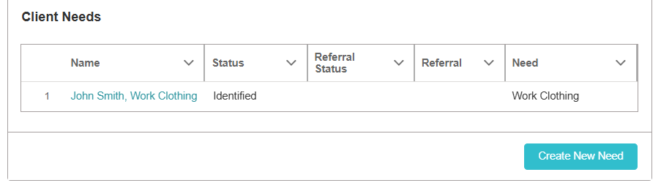
- You will now see the need listed on the case record under the Needs and Referrals tab.

- Repeat this process for all the needs the client has shared with you.

Generating Needs: PRAPARE Assessment
If you are having trouble uncovering your client’s needs or your organization does not already have a needs assessment, you may want to use the built-in PRAPARE assessment feature. This is a nationally standardized 23-question survey that will help you better understand the client’s situation and what resources may be appropriate for them. To initiate the PRAPARE Assessment:

- Click on the PRAPARE tab on the case record.
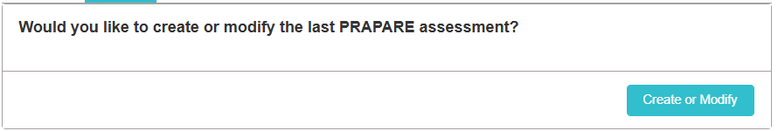
- Select Create or Modify.
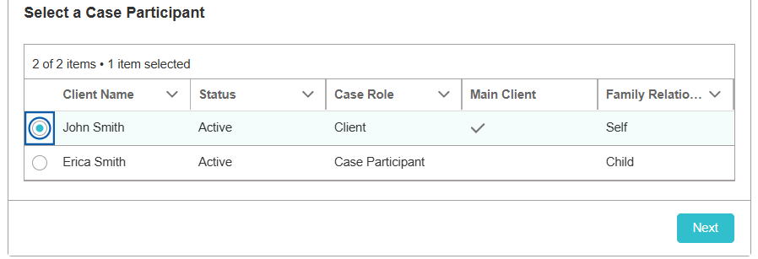
- Select which person on the case is answering the assessment and click Next.

- Ask your client as many of the assessment questions as you feel are necessary and appropriate. Depending on their answers, certain needs will be generated on the client record. At the end of the third page, click Submit Assessment and then Finish on the next page.
Note: None of the questions are mandatory, so if there are questions you don’t feel are relevant to the client, feel free to leave them blank and move on.

- Refresh the page and then go to the Needs and Referrals tab.
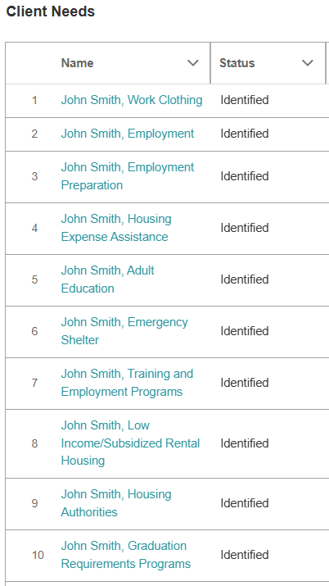

- You will now see all the needs identified from the assessment.

Managing Needs
Now that you have added needs to the case record, you can use these as your roadmap for the referrals you will be sending. However, for some of the needs identified, they may no longer be applicable or maybe you have already sent a referral for that client through other means. These are situations where you will want to update the status of the referrals, both to help yourself keep track of the open needs and for any other SYNC user who is in contact with this client. Updating the statuses of these needs will help reduce the duplication of efforts among the organizations helping the client.
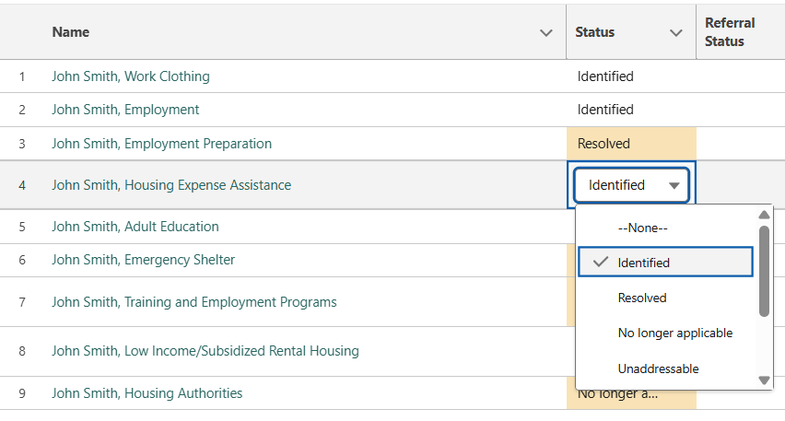
- Hover over the need you want to update. You will see a pencil icon appear. Click the Pencil and select the appropriate dropdown choice.


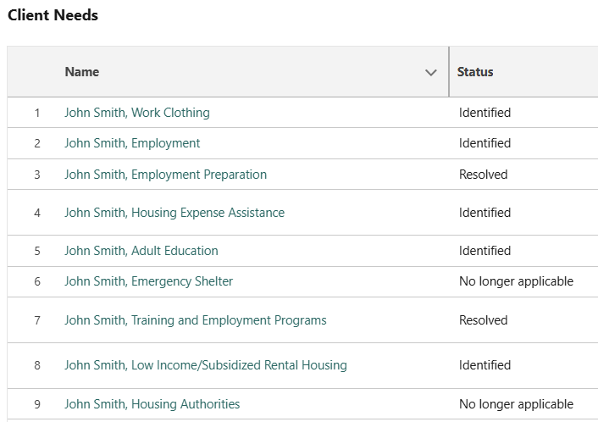
- Click Save Changes at the bottom of the page to finalize these changes. You will now see which needs still need to be worked on.

Referrals
Now that you have added needs to the case record, you can send referrals for your client. The client’s needs should influence the referrals you send for your client, as it gives you a roadmap for appropriate programs to refer to.
There are two types of referrals that you can make in SYNC, and we will be referencing them throughout the remainder of this training manual, so you may want to familiarize yourself with the following terms:
In-Network Referral: A referral that is sent to a SYNC participating program. It is also known as a “Closed-Loop Referral” because this allows the receiving organization to provide information about what happened with the referral. If you send an in-network referral, the SYNC user responsible for responding to referrals sent to their program will be notified via email and notification within SYNC.

- This type of referral is highly recommended as it exemplifies the collaborative nature of this network. When the referral is sent, the receiving organization will already have all the demographic and contact information they will need to reach out to the client, so it is strongly recommended to seek out in-network referrals before expanding your search to out-of-network referrals.
- In-network programs are notated with this icon:
Out-of-Network Referral: A referral that is sent to a program that does not participate in SYNC. When an out-of-network referral is sent, it is more for you to track the additional work you have done outside of SYNC to connect your client to the resource, such as calling the agency on their behalf or providing them with a website or email address.
- The out-of-network referral should be used primarily after you have reviewed the in-network options.

Sending Referrals
- From any open case, click on the Needs and Referrals tab.
- Determine how you’re sending the referral:
Option A
If you want to create a referral through a need on the client’s record, click the need you want to create a referral for under the “Client Needs” section.
Option B
If you want to send a referral directly to a program, under the “Create a Referral” section, click “To a Program using the CRG” and click Next.
NOTE: Some cases don’t have this button, so just skip to the next step if you do not see it

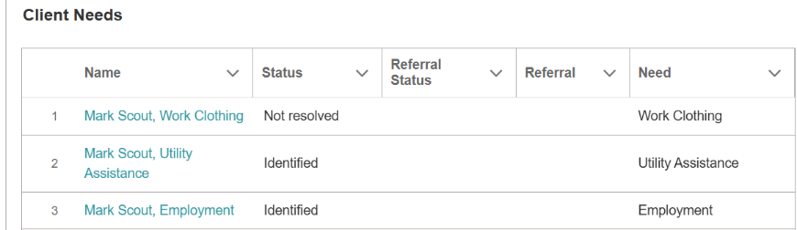

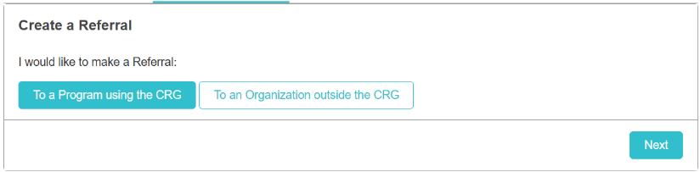
On the next screen, click on “Create a Referral” at the top right of the page.

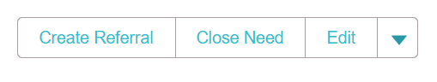

The need you originally selected will automatically populate. Click “Search Programs”.
Since the need prepopulates, there is no need to add a keyword.
Either type in a need in the “Select a Need” field or type in the name of the program or other identifying terms in the “Keywords” field. Then click “Search Programs”.
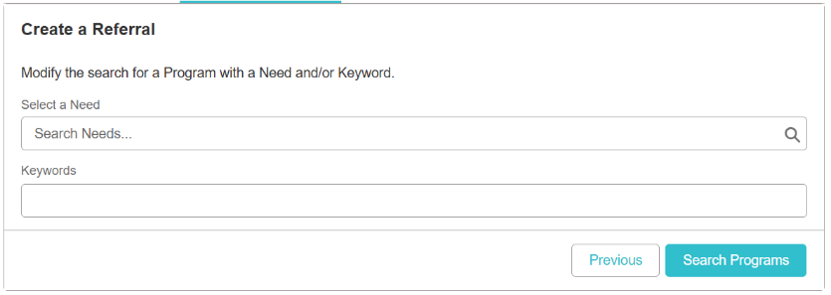

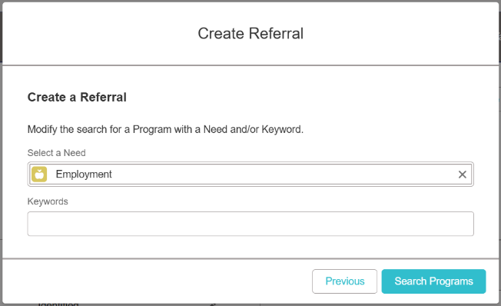

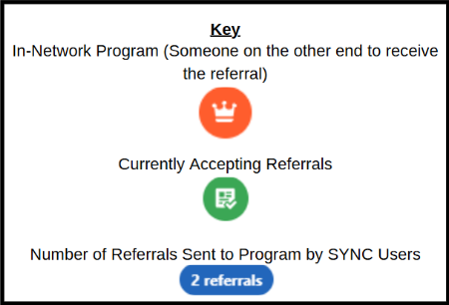
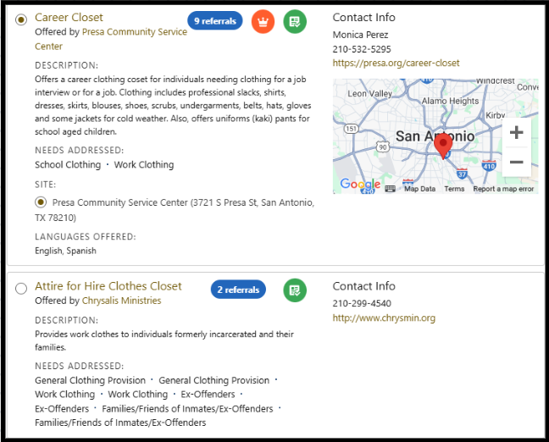
3. Read through the programs listed and determine which is the best fit for the client. If you click on the program, you will be able to see the address where the program is offered, and a map feature will appear.

4. Depending on if you choose an In-Network referral or an Out-Of-Network referral, the next steps will have some slight differences.

If the program is In-Network, under “Reason for Referral” write a note to provide additional context about the client and why the referral is being sent to their program.
If the program is Out-Of-Network, under “Reason for Referral” you will write a note for yourself and future SYNC users to see why the referral was made and how you provided the resource.

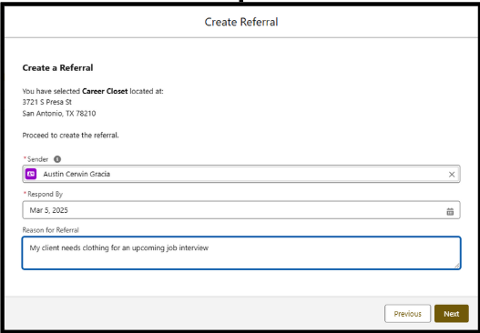

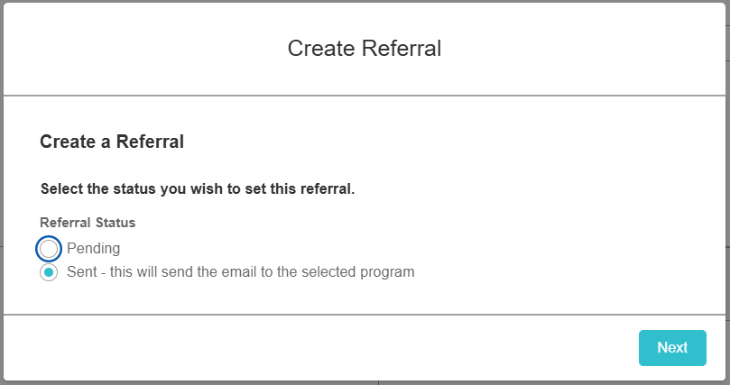
If the referral is to an In-Network program, leave it in “Sent” and click “Next”
If the referral is to an Out-Of-Network program, indicate which type of handoff you provided for the client and click “Next”.
- If you provided the website or a document, the handoff type would be Cold - Provided Resources to Client
- If you referred the client through other means, the handoff type would be Warm-Referral to Program.
- If you contacted the receiving organization for the client, the handoff type would be Warm-Contact on Client’s Behalf

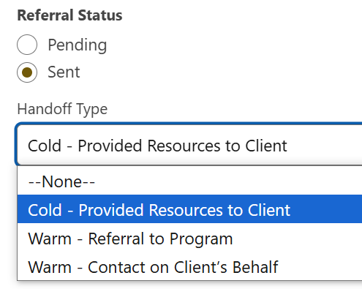

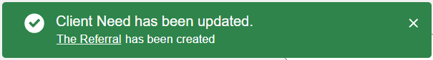
You will receive confirmation that the referral was sent at the top of the screen that the referral was sent.

Closing Referrals and Outcomes


Closing a referral means understanding the outcome of the referral. SYNC allows for the points of contact (PoC) at in-network referrals to inform the referral sender of what happened. Did the client receive the resource? Were they ineligible, and do they now need another referral? This response from the PoC allows all SYNC users who interact with the client to know about all the services they have received. To respond to referrals, the program PoC will follow these steps:
- You will receive a notification in SYNC (the bell icon at the top right of the page) AND an email from SYNC.
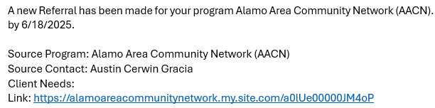
- Click the link in the email. It will take you into SYNC to the referral that has been sent to your program.
NOTE: As part of SYNC's security model, this email contains no information about the client.
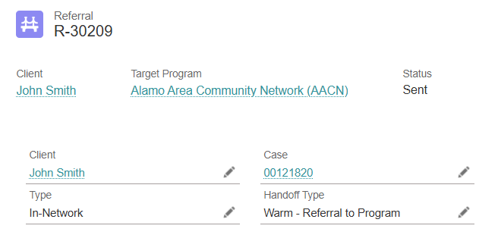
- Click on the client's name in the client record to find their contact information. Use this information to reach out to the client to determine whether they are eligible and if the program is the right fit for them, as you would with any other client who comes to your organization.
NOTE: Referrals must be responded to within 2 days.
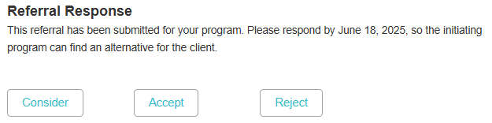
- Once you have made your attempt to reach out to the client, select the appropriate Referral Response.
NOTE: Whenever the referral's status is updated, the original sender will be notified so they are kept in the loop throughout the process.

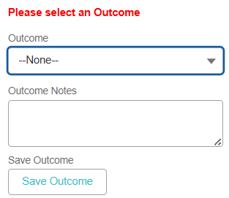

- Select the appropriate Outcome and fill out additional Outcome Notes.

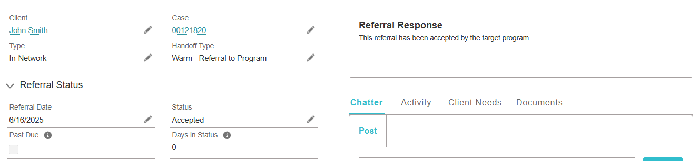
- The referral is considered closed when you either Accept or Reject it.

Status and Outcome Breakdown
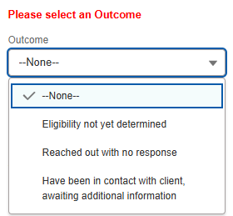
Consider: The client’s participation in the program is still not determined. You have made an attempt to contact the client but have yet to reach a conclusion on admitting them into the program.

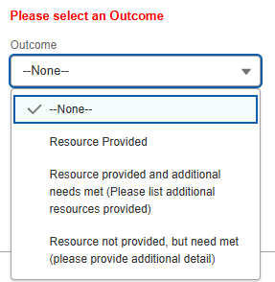
Accept: The client is deemed eligible and has been admitted into your program.

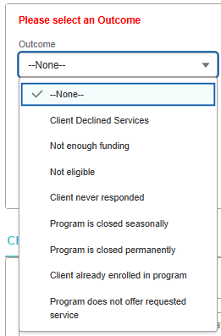

Reject: The client will not be entering the program.

Checking Outstanding Referrals
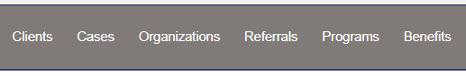
While our guidelines stipulate that referrals must be responded to within 2 business days, we recognize that this is not always possible. Here is a quick and easy way to see any referrals that are still awaiting a response.
- Click on the Referrals tab on the ribbon at the top of the page.
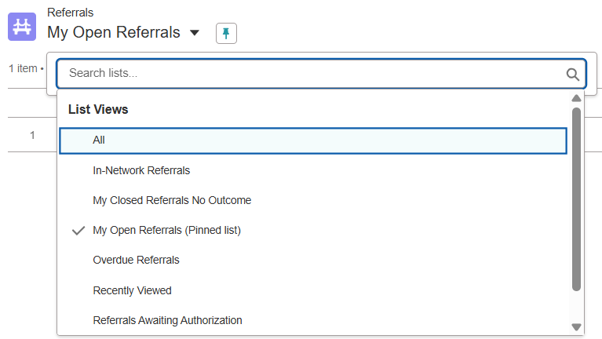
- Update the list view by clicking the drop-down list and selecting My Open Referrals.

NOTE: Click the “pin” icon to make this your default view

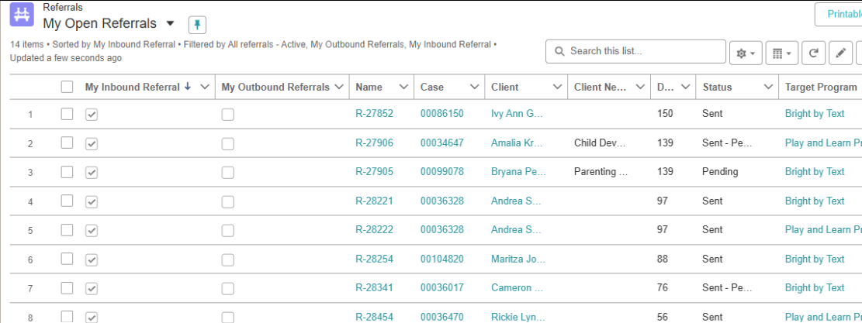
- You will now see all referrals that have been sent by you or to your program. You can sort your outbound referrals by clicking on the My Outbound Referrals column. You can sort your inbound referrals by clicking the My Inbound Referrals column.

